GROWTH AND CALCIFICATION RESPONSE OF THE COMMON COLLECTOR URCHIN, *TRIPNEUSTES GRATILLA*, TO PROJECTED CLIMATE CHANGE: EFFECTS OF WARMING AND ACIDIFICATION

A THESIS SUBMITTED TO THE GRADUATE DIVISION OF THE

UNIVERSITY OF HAWAIʻI AT MĀNOA IN PARTIAL FULFILLMENT

OF THE REQUIREMENTS FOR THE DEGREE OF

MASTER OF SCIENCE

IN

MARINE BIOLOGY

AUGUST 2020

By

Emily Sesno

Thesis Committee:

Judith Lemus, Ph.D. - Chairperson

Amy Moran, Ph.D.

Keisha Bahr, Ph.D.

Keywords: climate change, ocean acidification, ocean warming, calcification

**Acknowledgements:**

I would like to thank my advisor, Dr. Judy Lemus, and my committee, Dr. Amy Moran and Dr. Keisha Bahr for their continued support and guidance. Special thanks to Judy, who accepted me into her lab, embraced my many projects ideas, and helped me realize many of those goals. With her advice and assistance, I was able to maximize and round out my time in graduate school with various science-communication opportunities, outreach events, and creative explorations. Amy Moran provided necessary expertise into the complexities of invertebrate biology and always had open doors and feedback when I had questions. Keisha Bahr provided irreplaceable guidance throughout the experimental design, set-up, and maintenance process as well as essential statistical analysis advice. Throughout the experiment, I encountered set-backs, equipment failure, and frustrations, and Keisha stood by offering experienced advice and encouragement. I appreciated having these three strong women supporting my thesis research and without the input from each of them, I would not have been able to persevere as I did.

I would also like to Dr. Kanesa Duncan-Seraphin and University of Hawai’i Sea Grant for providing an amazing assistantship opportunity developing an elementary education science curriculum. Kanesa also provided incredible support and was a sounding board throughout the whole process. Thanks to Dave Cohen from the Division of Aquatic Resources (DAR) Sea Urchin Hatchery for providing the research specimens and teaching me about the hatchery and to Tina Carvahlo at the Biological Electron Microscope Facility (BEMF) for showing me the way on the Scanning Electron Microscope (SEM). This research would also not have been possible without funding support from the Colonel Willys E. Lord, DVM and Sadina L. Lord Scholarship Fund and the Charles H. and Margaret B. Edmondson Research Fund.

To my fellow graduate students and friends; thank you for supporting, empathizing with, and humoring me over the years. To Lizzy Monaghan and Jack Runburg for babysitting urchins while I was away; Ariana Huffmyer for statistics help and extreme patience; and my interns Suhaila Ng and India Ching for their eager willingness to help. And of course, none of this would have been possible without my family – parents, siblings, and partner. This work is dedicated to my grandmother, Betsy Sanderson, who set the example that women in science are forces to be reckoned with and supported me in many ways over the years.

**ABSTRACT**

As climate change leads to alterations in ecosystem and organism functions, the need to explore the breadth of effects is paramount. Increased sea surface temperatures (SST) and ocean acidification (OA) are major contributors leading to alterations in body size and calcification in marine invertebrates, however the full effects are not fully understood. Ecologically important invertebrates, such as sea urchins, calcify in both larval and post-metamorphic life stages, requiring long-term studies that cover changes into adulthood. The goal of this research is to contribute to the understanding of potential climate change impacts on post-metamorphic calcifying marine invertebrates, specifically the common collector urchin native to Hawaiʻi, *Tripneustes gratilla*. In this experiment, individual *T. gratilla*  from juvenile (~16 mm) to adult (~60 mm) were grown under projected environmental conditions of warming (+2°C) and increased acidity (-0.3 pH units) and a combination of both. The objectives were to explore the sensitivity of *T. gratilla* to warming and OA through comparisons of 1) growth (% change from initial to final diameters) and 2) calcification (calculated ratios through Scanning Electron Microscopy (SEM) images of cross-sections) of the urchin spines. Additional proxies of growth (relative spine length (calculated proportionally to body size) and calcification (number of dropped spines) were also measured. Results of this research reveal that warmer temperatures increased growth while acidification reduced calcification at the base of spines with no interactive effects of the two factors. Urchins in low pH treatments shed their spines more readily than those in ambient pH, regardless of temperature, indicating that calcification may be hindered in these acidic conditions. These results suggest that while survivorship and growth were normal, the energy required to keep up with calcification, regardless of temperature change, may be inhibitive for the long term.

**TABLE OF CONTENTS**

Acknowledgements……………………………………………………………………….……….ii

Abstract……………………………………………………………………………...……………iii

Table of Contents…………………………………………………………………………………iv

List of Tables……………………………………………………………………………….……...v

List of Figures……………………………………………………………………………….……vi

Introduction…………………………………………………………………………………….….1

Methods..........................................................................................................................................19

Study Animal Collection and Acclimation…………………………………………….....11

Experimental Design………………………………………………………………..……11

Experimental Treatments and Data Collection…………………………………………...13

SEM and Image J………………………………………………………………………....15

Statistical Analyses……………………………………………………………………....18

Results…………………………………………………………………………………………....19

Environmental Conditions .................................................................................................19

Effect on Growth………....………………………………………………………….…...20

Effect on Calcification…………………………………………………………………...22

Effect on Relative Spine Length………………………………………………………....23

Effect on Spines Dropped………………………………………………………………..23

Discussion……………………………………………………………………………..…………26

Appendix………………………………………………………………………………………....33

References………………………………………………………………………………………..38

**LIST OF TABLES**

Table 2.1. Mean Condition Results………………………………………………………………14

Table 2.2. Macro for ImageJ Processing…………………………………………………….......33

Table 2.3. R Script.........................................................................................................................33

Table 3.2 ANOVA for Models......................................................................................................25

Table 4.1 Compilation of Multi-stressor Studies ..........................................................................35

Table 4.2 Comipilation of Acidification Studies...........................................................................36

Table 4.3 Compilation of Warming Studies..................................................................................37

**LIST OF FIGURES**

Figure 1.1: The Carbonate System in Seawater…………………………………………………...2

Figure 1.2: *T. gratilla* Distribution Map…………………………………………………………..4

Figure 1.3: *T. gratilla* Life Cycle………………………………………………………………….5

Figure 1.4: Echinoid Spine..............................................................................................................6

Figure 1.5: *T. gratilla* Larva Results……………………………………………………………....9

Figure 2.1: Experimental Set up and Schematic…………………………………………………12

Figure 2.2: Urchin Schematic……………………………………………………………………15

Figure 2.3: Spine Cut Diagram ………………………………………………………………….16

Figure 2.3: SEM and ImageJ…………………………………………………………………….17

Figure 2.4: SEM Dust…………………………………………………………………………....17

Figure 3.1: Experimental Conditions…………………………………………………………….19

Figure 3.2: Percent Growth Over Time ..........…………………………………………………..21

Figure 3.3: Calcification Ratio....…………………………………………………………….…..22

Figure 3.4: Relative Spine Lengths.....…………………………………………………………...23

Figure 3.4: Dropped Spine Count………………………………………………………………..24

Figure 4.1: SEM Comparisons at Tip and Base............................................................................28

Figure 4.2: SEM of Microspines ...................................................................................................29

Figure 4.3: SEM Malformations and Etching ...............................................................................31

**INTRODUCTION**

**A Changing Climate**

Since the industrial revolution, increased burning of fossil fuels, intensive agriculture, and deforestation have led to a rise in greenhouse gas emissions from 278 parts per million (ppm) in 1750 to over 400 ppm in 2019 (Gattuso et al., 2015). Greenhouse gases create a warming effect of the Earth and its oceans by preventing heat from escaping the atmosphere. At the same time, the gases absorb into the ocean and alter the sea water chemistry. The ocean can act as sink by absorbing more than 90% of excess heat since the 1970’s and taking up 20-30% of anthropogenic atmospheric carbon dioxide (CO2) emissions since the 1980’s, a major greenhouse gas contributor (IPCC, 2019).

While this absorption of heat and CO2 can buffer immediate changes to the atmospheric and terrestrial environment, the rapid rate of change to the ocean is known to be a major threat to marine life worldwide (Gattuso et al., 2015). The rate of ocean warming has more than doubled in the last 25 years and ocean acidity has increased by 25% (IPCC, 2019), creating challenges for organisms, populations, communities, and ecosystems. Following a ‘baseline scenario’ without mitigation, global sea surface temperatures (SST) are expected to rise 1.5 to 2.4°C by 2050 and up to 5.4°C by 2100. Sea surface pH will likely drop by 0.2 to 0.32 pH units by 2100 (IPCC, 2019).

Increased SST impact coral reef ecosystems, organism growth, and home range (Gattuso et al., 2015). In particular, marine ectotherms, which represent about 99% of all known species worldwide, have shown a trend of declines in mean body size due to increased temperature, however this response varies across taxa and can depend on developmental stage, life-history traits, feeding, and/or other environmental parameters (Kroeker et al., 2013; Ohlberger, 2013; Sheridan & Bickford, 2011). All of these responses to warming are complex and interconnected, often having interactive effects with other environmental changes (IPCC, 2019), making interpretation complex and difficult (Przeslawski at al., 2008).

Ocean uptake of CO2 changes seawater carbonate chemistry in a process called ocean acidification (OA) and can influence an organism’s ability to calcify and build hard skeletons (Emerson et al., 2017; Kleypas et al., 2006). Dissolved CO2 forms carbonic acid (H2CO3) in seawater, which then dissociates into bicarbonate (HCO3-), carbonate (CO32-) and hydrogen ions (H+) (Emerson et al., 2017; Kleypas et al., 2006). This results in lower pH and a decrease in the calcium carbonate (CaCO3) saturation state (Ω) (Figure 1.1) (Dupont et al., 2010; Emerson et al., 2017; Kleypas et al., 2006).



**Figure 1.1.** The carbonate system in seawater, while complex, moves through a predictable series of equilibria with specific dissociation constants (K1 and K2). (reproduced from Kleypas et al., 2006)

Because CaCO3 is an important component in shells and skeletons of calcifying marine organisms, often as aragonite or calcite, it is thought that shifts in Ω can negatively influence the integrity of these hard parts (Collard et al., 2016a; Emerson et al., 2017). Recent research suggests, however, that reduced calcification is likely due more to lowered pH in surrounding seawater than a reduction in available carbonate ions (Cryonak et al., 2015). In many calcifiers, the dissolved inorganic carbon (DIC) needed to build skeletal components comes from dissolved carbon dioxide or bicarbonate rather than carbonate, so a reduction of saturation states is likely not a direct threat to calcification (Dubois, 2014a). In a meta-analysis of 228 studies, results revealed that corals, crustaceans, coccolithophores, mollusks, and echinoderms have been shown to be sensitive to OA in growth, calcification, survival, or abundance (Kroeker et al., 2013). Organism responses also vary through life-history stages, often having different results in larval versus adult stages (Albright et al., 2012a).

While studies exploring the effects of warming and acidification seperately are valuable to build understanding of their impacts, these changes are predicted to occur simultaneously, often with interactive effects. Combined effects can act synergistically, further confounding the negative impacts, or antagonistically, often with temperature mitigating the negative impact of acidification (Bahr et al., 2016; Ban et al., 2014; Byrne & Przeslawski, 2013; Dworjanyn & Byrne, 2018). Because of the complexities and layered dynamics of climate change as well as the variable responses across taxa and life-history, organism response to these environmental changes can be difficult to interpret (Ries et al., 2009).

**Echinoderms**

The exclusively marine taxa Echinodermata has a high-magnesium calcite (Mg-calcite) skeleton that is one of the most soluble forms of calcium carbonate. Calcification occurs in both larval and juvenile stages, making them particularly sensitive to OA. (Collard et al., 2016a; S. Dupont et al., 2010; Emerson et al., 2017). With over 7,000 species subdivided in five classes -- ﻿crinoids (sea lilies and feather stars), asteroids (starfishes), ophiuroids (brittlestars), echinoids (sea urchins and sand dollars) and holothuroids (sea cucumbers) -- full understanding of the variety of echinoderm response to climate change is difficult to obtain (Dupont et al., 2010; Ries et al., 2009).

One echinoid, *Tripneustes gratilla*, is an ecologically important species of sea urchin native to the Hawaiian Islands and also found in coastal regions throughout the Pacific, Indo-Pacific, Indian Ocean, and the Red Sea (Figure 1.2). Because of this broad distribution, *T. gratilla* have been found to survive in temperatures that range from the lowest 15°C in the subspecies *T. gratilla elatensis* in the Red Sea (Dafni, 1992), to the highest of 32°C in Madagascar (summarized by Toha et al., 2017). Commonly known as the ‘collector urchin’, *T. gratilla* gets the name from its gathering behavior, placing rocks, sponges, or bits of algae on the aboral surface of the test, purportedly to protect against predators or elements (Toha et al., 2017). Reductions in this covering behavior, both ability and reaction time to first cover, has been observed in the urchin *Strongylocentrotus intermedius* when exposed to long-term warming (~3° above ambient) conditions (Zhang et al., 2017).

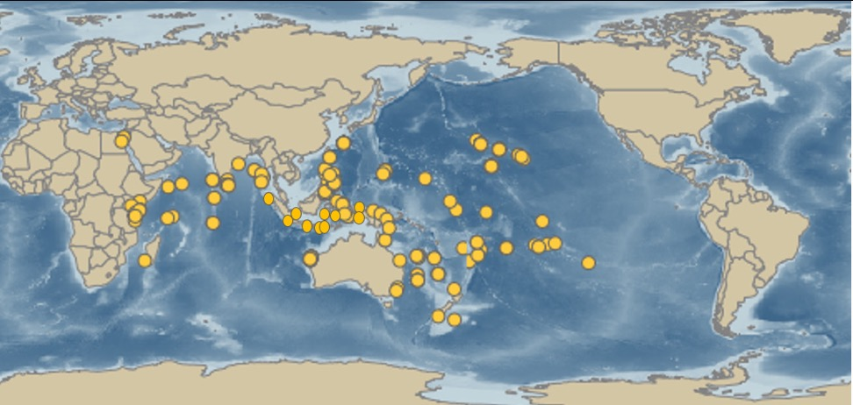

**Figure 1.2.** Distribution of *Tripneustes gratilla.* (Toha et al., 2017)

Collector urchins are one of the fastest growing echinoid species, reaching reproductive maturity at 50-60 mm test diameter (TD) in less than a year (J. Dafni, 1992; Dworjanyn & Byrne, 2018; Toha et al., 2017), and attaining a maximum size of 160 mm TD in 4-5 years (Rahman et al., 2014). This fast rate of growth makes them ideal organisms for long-term and reproductive studies (Lawrence, 2001). *Tripneustes gratilla* are broadcast spawners that generally follow an annual reproductive cycle but have also been found to spawn year-round. Larvae live in a free-swimming planktonic stage for about 20-40 days before undergoing metamorphosis and settling into their adult form (Figure 1.3) (Toha et al., 2017).

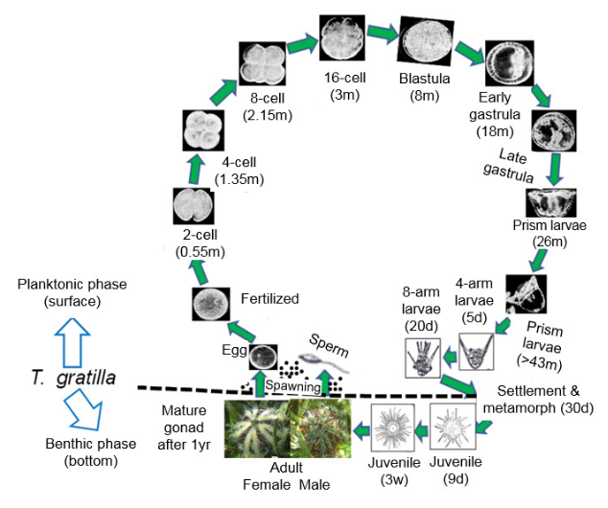

**Figure 1.3.** The life cycle of *Tripneustes gratilla* (reproduced from Toha et al., 2017)

Echinoderms are known for their regenerative ability, such as ﻿the regrowth of asteroid and crinoid arms when shed intentionally as defense or due to traumatic event (Micael et al., 2009; Moureaux et al., 2010). Similarly, urchins can regenerate spines, tube-feet, and ﻿pedicellariae (Emerson et al., 2017). In addition to the main skeleton, or test, these external appendages serve important purposes for protection, defense, sensory abilities, and locomotion (Collard et al., 2016b). The spines of *T. gratilla* are similar to those of regular echinoids consisting of three main parts: 1) a base that creates a ball-and-socket formation with a tubercle on the test, 2) a milled ring, and 3) a tapered shaft (Heatfield, 1971) (Fig.1.4). The internal meshwork of spines trabeculae (steroem), is a mixture of both mineral and organic components (stroma) (Gorzelak et al., 2011). Because spines are made of the same highly soluble Mg-calcite material as the test (Byrne et al., 2014); external stressors such as OA could therefore hinder re-growth and compromise adult urchins’ ability to survive (Emerson et al., 2017). While the exact mechanism of calcification in echinoderm spines is not entirely understood, adult urchins are thought to grow and regenerate spines through an initial amorphous calcium carbonate (ACC) phase that eventually transforms into a single crystal of calcite (Politi et al., 2004). This process of biomineralization is suggested to be universal across the phylum Echinodermata, with similar structures and molecules involved in skeletogenesis (S. Dupont et al., 2010; Gorzelak et al., 2011). The crystaline structure has interconnecting bridges that allow urchin spines to be strong and stiff to endure compression force while simultaneously creating a brittle nature under torsion to break easily (Dubois & Ameye, 2001; Moureaux et al., 2010b; Tsafnat et al., 2012).

**Figure 1.4**. Diagram of a spine with a regenerating tip of an echinoid urchin showing a) the three main parts of a full spine and b) the steroem meshwork in the regenerating portion with interconnecting bridges. (reproduced from Gorzelak et al., 2011).

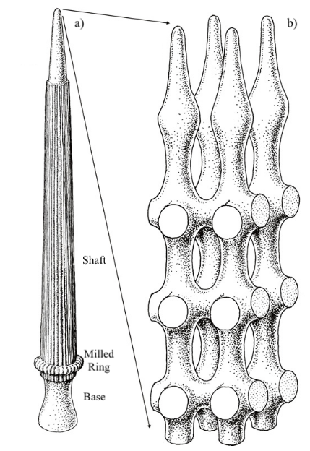

**Importance**

Echinoderms play necessary roles in many vulnerable ecosystems, providing food for other animals and humans, acting as bioturbators, and influincing algal overgrowth through grazing (Dupont et al., 2010). *Tripneustes gratilla* are ecologically important, often acting as ecosystem engineers by maintaining balance of algal coverage, and are economically valuable, supporting small-scale fisheries and providing value in commercial trade (Toha et al., 2017; Westbrook, Ringang, Cantero, & Toonen, 2015). These urchins have also been used by the EPA as an indicator of water-quality, with the success of fertilization a measure of toxicity in industrial effluents (Fung, 2014).

Invasive algae, specifically of the genera *Caulerpa* spp., *Eucheuma* spp., *Gracilaria* spp., *Acanthophora* spp., and *Kappaphycus* spp. were intentionally and/or unintentionally introduced into Kāneʻohe Bay, Hawaiʻi in the 1970’s. The algae has potential to smother coral reefs and contribute to phase shifts from coral-dominated to algae-dominated ecosystems (Conklin & Smith, 2005; Westbrook et al., 2015). *Tripneustes gratilla* are slow moving generalist eaters, traveling only about 1.3 meters per day, and have been found to feed on whatever seagrasses or macroalgae they come across (Toha et al., 2017; Westbrook et al., 2015). In conjunction with manual removal, *T. gratilla* have been successfully used as biocontrol for invasive algae in Hawaiʻi and are therefore important for maintaining balance in the reef ecosystem (Neilson et al., 2018; Westbrook et al., 2015).

**Previous Research**

Sea urchins are common model organisms for invertebrate research due to their importance within an ecosystem, potential sensitivity to environmental changes, and ease of spawning (see tables 4.1-4.3 for compilation of recent studies of climate change impacts on sea urchins). Many studies investigating multi-stressor climate change impacts on *T. gratilla,* focus on fertilization (Byrne et al., 2010) or larval and early development stages (Sheppard Brennand et al., 2010). Those that look at juvenile to adult stages use the Australian variety of *T. gratilla* (Byrne et al., 2014; Dworjanyn et al., 2018; Mos et al., 2015). Studies investigating *T. gratilla* in Hawaiʻi have generally been limited to feeding preferences for reference to their ecological importance as a biocontrol for invasive algae (Neilson et al., 2018; Stimson et al., 2007; Westbrook et al., 2015)

Byrne et al., (2010) found that fertilization in *T. gratilla* in Australia is resilient to projected temperature and pH changes with no significant effects across a combination of temperature and pH treatments (﻿T: ambient, +4°C, +6°C; OA: ambient pH, -0.3 pH units, -0.4 pH units, -0.6 pH units). Because fertilization takes place in shallow coastal habitats, increased adaptation to this fluctuation could be reflective of the variability of environmental conditions.

Although fertilization is robust, larval stages of this species could be particularly sensitive to environmental changes since they spend about 30 days in the water column (Byrne et al., 2010). Larvae have calcite rods that are necessary for support, swimming, and feeding, making them particularly susceptible to effects of OA. In addition, temperature has been found to shorten the time at which individuals are in their planktonic stages, potentially altering life-history stages (Sheppard Brennand et al., 2010). In an experiment looking at projected climate change for Australia (T: ﻿+3–6 °C; OA: -0.3–0.5 pH units), Sheppard Brennand et al. (2010) found interactive effects of OA and warming during larval development. Growth positively correlated to increased temperature, regardless of pH treatment, until a thermal threshold (30°C) was reached. On the other hand, growth was negatively correlated with increased acidity, although warming offset some of those effects (Fig. 1.5). A close up of a cat

**Figure 1.5**. Results of a multi-stressor (Temperature and pH) study on the larval development of *Tripneustes gratilla* (reproduced from Sheppard Brennand et al., 2010)

Effects of temperature and acidification in post-metamorphic (juvenile to adult) life stages of *T. gratilla* has been investigated in two studies in Australia. Byrne et al. (2014) and Dworjanyn & Byrne (2018) used three pH treatments (control (8.1), -0.3 pH units (7.8) and -0.5 (7.6)) and three temperatures (control (22 °C), +3° (25 °C), and +6° (28 °C)) and a combination of all over 146 days. Byrne et al. (2014) found that OA significantly decreased test thickness but this difference varied with temperature. Similarly, crushing strength (force required to crush a live urchin as would occur in a predation event) was reduced in low pH but increased in warm conditions. In addition, Dworjanyn & Byrne (2018) found that temperature and acidification had interactive effects on reproductive potential, with warming increasing gonad index and OA decreasing it. However, at the lowest pH of 7.6, virtually no gonads were present. Growth increased in both warmer temperatures (+3°C and +6°C) than ambient and decreased in the lowest pH treatment (-0.5 pH units) with no interaction between these factors. These studies reveal the complexity of multi-stressor experiments that are further exacerbated by the difficulty of maintaining long-term experiments. Research on *T. gratilla* reflect similar results to other species (as indicated in tables 4.1-4.3), however results of these studies also reveal that sea urchin response to environmental changes are variable within and between species, making it difficult to predict responses.

This research seeks to contribute to and expand on the current understanding of the effects of climate change, specifically warming and acidification, on this ecologically important sea urchin. By investigating *T. gratilla* native to Hawaiʻi, I aim to add to the understanding of subtropical populations to include these tropical individuals to further identify responses of those nearer to their thermal maximum. I predicted that 1) temperature would influence growth negatively beyond a thermal threshold but may enhance growth if within the normal range and 2) acidification would impede calcification, with potential interactive effects of temperature offsetting the negative effects of acidification.

**MATERIALS AND METHODS**

**Study animal**

This research was conducted at the University of Hawaii’s Hawaiʻi Institute of Marine Biology (HIMB) on Moku o Loʻe in Kāneʻohe Bay Hawaiʻi. Juvenile *Tripneustes gratilla* from the same stock (n = 24, mean diameter = 7.54 ± 0.29 mm, spawned in July, 2018) were obtained from the Hawaiʻi Department of Land and Natural Resources (DLNR) Division of Aquatic Resources (DAR) sea urchin hatchery in September of 2018, transported to HIMB, and acclimated to Kāneʻohe Bay ambient conditions for two weeks in flow-through seawater tables. Body size (test diameter (mm)) was measured weekly using Neiko digital calipers (Resolution: 0.01mm, Accuracy: 0.02mm). Two measurements of diameter were taken to account for nonsymmetrical shapes in test formation. Growth was calculated to standardize to initial size and presented as a percent ((final – initial / initial diameter)*100). Urchins were fed in excess the commonly found invasive red alga, *Gracilaria salicornia,* collected from the shores of HIMB. Although this may not reflect realistic food availability, this protocol is consistent with other long-term urchin growth studies (Albright et al., 2012b; Dworjanyn & Byrne, 2018; Emerson et al., 2017), and represents a “best case scenario” in terms of nutritional status of the urchins. Throughout the 126-day experiment, survival was close to 100%, with only one mortality out of 24 urchins on day 103.

**Experimental Design**

The experiment was conducted in a flow-through system at HIMB modified from the low-cost, high-flow system outlined in Jokiel et. al. 2014. Conditions tracked daily and seasonal fluctuations of environmental parameters (i.e., temperature, pH, salinity, dissolved oxygen). Treatments consisted of two temperature regimes (present day and near-future +2°C), two pH levels (present and near-future -0.3 pH units), and the combination of both. These manipulations represented future climate change conditions projected to occur by 2100 (IPCC, 2019) (Figure 2.1). The control was represented by ambient conditions of both pH and temperature of incoming seawater.

Unfiltered seawater was pumped directly from Kāneʻohe Bay from about 2m depth into eight 6-gallon header buckets where seawater temperature and pH were manipulated. Two-tiered seawater tables (n=2) allowed each header to gravity-feed into three 8L tanks, where individual urchins were housed. Two replicate systems led to a total of 24 microcosms with 6 urchins per treatment (Fig. 2.1).

Water flowed into tanks at a rate of 0.9 - 1.2 L min-1, resulting in a complete volume exchange every 6 - 8 minutes. This exchange also allowed for sufficient oxygen saturation levels above 95% (Byrne et al., 2014). The experiment ran for 126 days, excluding a two-week acclimation and two-week conditioning time period. By the end of the study, all urchins reached mature adult size of at least 60mm (Byrne et al., 2014; Dworjanyn & Byrne, 2018).

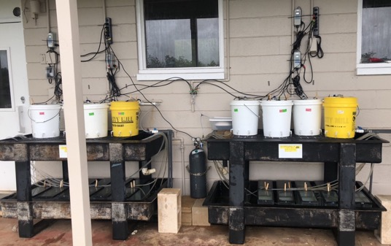

**Figure 2.1**. Experimental set-up (left) at HIMB and schematic diagram representing the design and treatments in one replicate of the system (right).

**Experimental Treatments and Data Collection**

Temperature was controlled using ﻿submersible titanium heaters (Finnex©, TH-800, 800 W). Seawater pH was manipulated by direct CO2 bubbling through a hydro pump to maximize diffusion (Jokiel et al., 2014). Ambient pH conditions without the hydro pump were also bubbled with air to ensure consistency.

Because of the open-system, all treatments tracked natural daily and seasonal fluctuations. No treatment was applied for the first two weeks during acclimation. After which, treatments were ramped up for two more weeks at a rate of -0.02 pH units day-1 and +0.06°C day-1 until the desired conditions were reached, marking day one of the experiment. Temperature (°C), salinity ﻿(‰), and dissolved oxygen (% saturation) were measured each week at mid-day (11:00 – 14:00 h) to ensure consistent desired environmental conditions. Water samples were collected at the same time for use in titrations and photometric pH determinations for all headers and tanks. All procedures for titration and pH determination were followed according to the Guide for Best Practices for Ocean CO2 Measurements Standard Operating Procedures (SOP) (Dickson, Sabine, & Christian, 2007).

Total alkalinity was measured weekly using an automatic titrator (Titrino© Plus 877, Metrohm) with pH glass electrode (9101 Herisau, Metrohm©). The automatic titrator was checked and confirmed for precision with certified reference materials (Batch 127 from A. Dickson Laboratory, Scripps Institution of Oceanography). Additional seawater parameters were calculated using the program CO2SYS (Pierrot et al., 2012) with stoichiometric dissociation constants (K1, K2) as redefined (original by Mehrbach et. al., 1973) by Dickson & Millero (1987). Titrations followed SOP 3b: Determination of total alkalinity in sea water using an open-cell titration (Dickson et al., 2007). Seawater pH was determined spectrophotometrically (pHTotal) each week using *m*-cresol purple dye (Sigma-Aldrich© #857890). Procedures for pH followed SOP 6b: Determination of the pH of sea water using the indicator dye *m*-cresol purple (Dickson et al., 2007). In addition to the above procedure, pH was checked frequently using an Accumet© AP72pH/mV/temperature meter (pHNBS) to confirm stability between sampling.

**Table 2.1**. Experimental treatments and environmental conditions throughout the course of the 126-day experiment.

|  |  |  |  |  |  |  |
| --- | --- | --- | --- | --- | --- | --- |
| **Treatment** | **Temperature**  (°C) | | | ***p*CO2**  (μatm) | **pH**T | **AT**  (μmol kg-1) |
| Mean ± SE | Min | Max | Mean ± SE | Mean ± SE | Mean ± SE |
| Control:  Amb T, Amb pH | 25.4 ± 0.12 | 22.1 | 28 | 493 ± 11 | 7.96 ± 0.002 | 2181 ± 2 |
| Amb T, Low pH | 25.4 ± 0.12 | 22.1 | 28 | 1069 ± 11 | 7.66 ± 0.005 | 2182 ± 2 |
| High T, Amb pH | 27.3 ± 0.11 | 23.8 | 29.7 | 537 ± 12 | 7.96 ± 0.002 | 2180 ± 2 |
| High T, Low pH | 27.3 ± 0.11 | 23.8 | 29.5 | 1121 ± 11 | 7.68 ± 0.005 | 2183 ± 2 |

**Spines, SEM, and Image J**

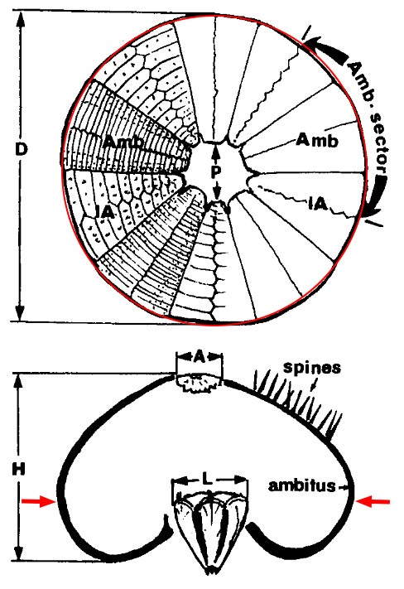

**Figure 2.2**. Diagram of *Tripnuestes gratilla* from below and side view. Red line and arrows indicate the location of the ‘skirt’ (below the ambitus) where spines were plucked. D: test diameter; H: height; A: apical plate diameter; P: peristome; L: Aristotle’s Lantern; IA: interambulacral plate; Amb: ambulacral plate; Amb-sector is the whole ambulacrum and attached interambulacral columns (adapted from J. M. Dafni & Erez, 1987).

At the end of the 126-day experimental period, spines were plucked from each individual urchin (n=23) for use in scanning electron microscopy (SEM) at the Biological Electron Microscope Facility (BEMF) at the University of Hawaiʻi at Mānoa. Approximately 10–20 spines were haphazardly selected from just below the ambitus (the widest diameter) of the urchin test (Fig. 2.2). Based on preliminary trials and procedure from Albright et al., 2012, spines were soaked in 10mL of 10% bleach solution for 20 minutes to remove organic material, rinsed in distilled water to remove bleach residue, and dried at 60°F for 24 hours. All collected spines were measured for length using Neiko digital calipers (Resolution: 0.01mm, Accuracy: 0.02mm), pooled together per individual to create randomness and three were randomly selected to be prepped for SEM imaging. Relative spine lengths were calculated as a percent of TD ((spine length/diameter)*100)) (Mos et al,, 2015; Mos et al., 2016). Each selected spine was cut 2 mm from the tip and 2mm from the base using a fresh razor blade and air blasted to remove dust particles (Fig 2.3). Although the term “base” specifically applies to the unique structure at the bottom of the spine, the base of the spine in this study is used to refer to the lower portion that was cut. In the event that a spine broke during the mounting process, another was randomly selected. The base and tip selections were mounted cut-side upward on aluminum stubs using carbon conductive adhesive paint and coated with gold/palladium for 45 seconds in a Hummer 6.2 sputter coater. Cross-sections were viewed with a Hitachi S-4800 Field Emission Scanning Electron Microscope at an accelerating voltage of 5.0 kV. Because the SEM allows for maneuverability on the X, Y, and Z planes, stubs could be rotated to ensure a direct overhead image was captured.

**Figure 2.3.** Spines were cut 2 mm from the tip and 2 mm from the base, as indicated by the red line. Spines were mounted upright and cross-sections imaged on the Scanning Electron Microscope (SEM).

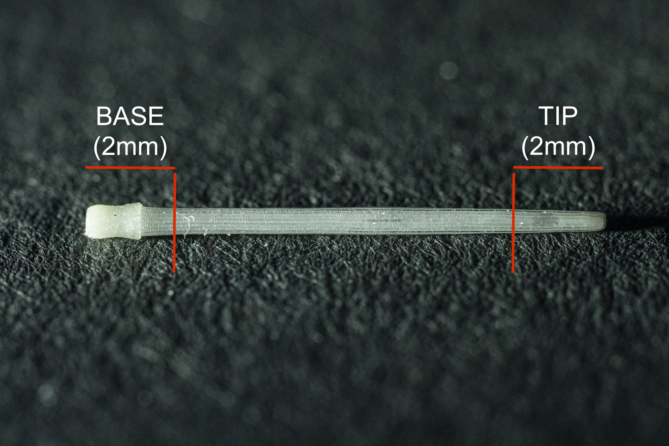

Images were analyzed using ImageJ (NIH, Bethesda, MD, USA). A manual selection of each spine cross-section was made to include only the inner portion of the spine, excluding the edges. A custom macro script was run that converted each image to binary (black for calcified material; white for voids), adjusted for outlying bright spots, and calculated a calcification ratio (Fig. 2.3, Table 2). Although great care was taken to remove dust before SEM imaging, some spines still had small specks that could interfere with results and one was completely obscured by dust (Fig. 2.4b). Separate ratios were calculated for the entire image as well as each half, so if dust was visible images were rotated so it occupied only one side. Analaysis was conducted on only one side per image across all images. If no dust was visible, the side for analysis was randomly selected using a random number generator, as there was no difference in ratio between sides (ANOVA, p=0.674).

At the end of the experimental period, it became clear that urchins were differentially shedding spines across treatments. To quantify this, urchin tanks were cleaned of feces and urchins not fed in order to keep tanks clean. After two days, spines that were loose on the bottom of the tanks were counted in each tank and used for further analysis.

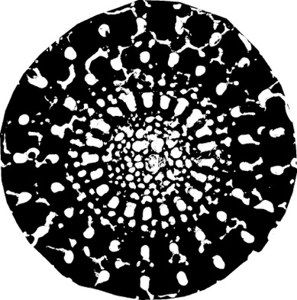

a.

b.

**Figure 2.4**. An example SEM cross-section of the bottom of a spine from an ambient temperature and pH with area selected to be analyzed (a). The same spine excluding the ridges of the outside perimeter and converted to binary for analysis (b).

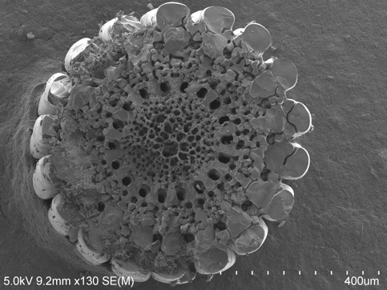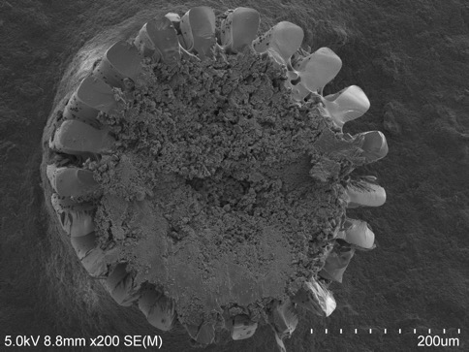

a.

b.

**Figure 2.5**. An example SEM cross-section from the base of a spine from a control urchin with partial dust on left side (a). The only spine with complete dust coverage (b) (tip from a high temperature, ambient pH condition) was excluded from analysis. Note: Tips were smaller, so images above are not at the same scale for ease of viewing.

**Statistical Analyses**

Residuals were checked for normality and confirmed with the Shapiro-Wilk test and homogeniety of variance was confirmed using Levene’s test. Temperature and pH treatment condition data were not normal, so were analyzed using a Kruskal-Wallis test. Effect of temperature and pH treatments on growth (%), calcification ratio, and relative spine length (% of TD) were analysed using linear mixed effects models in the *lme4* package (Bates, et al. 2015) in R Statistical Programming (R Core Team, 2018). Temperature and pH were included as fixed factors with individual urchin included as a random effect. Significance of effects was determined using a type II analysis of variance (ANOVA) producing a deviance table with Wald chi-square tests in the *car* package (Fox et al. 2019). Alpha was set to 0.05 for all analyses. Analysis of dropped spines was conducted using a Kruskal-Wallis test (Alexis Dinno, 2017) as the normality assumption was violated. Data visualization and analysis was conducted using the programs JMP® Pro 13.1.0 (SAS Institute Inc., 2019) and R Version 1.2.1335 (R Core Team, 2018).

**RESULTS**

**Treatment Conditions**

The achieved conditions of header tanks were not different between the same temperature and pH treatments, so were pooled with analysis of environmental conditions in the tanks. Temperatures were not significantly different among all ambient tanks (Chi square= 1.96; p = 0.9995, df = 12) and among all high temperature tanks (Chi square= 8.69; p = 0.7293, df = 12), but were different between ambient and high temperature tanks (Chi square= 148.13; p <0.0001, df = 24) (Fig. 3.1a). Similarly, pH levels were not significantly different among all ambient tanks (Chi square= 19.60; p = 0.0750, df = 12) and all low pH tanks (Chi square= 13.54; p = 0.3310, df = 12), but were different between ambient and low pH tanks (Chi square= 323.46; p <0.0001, df = 24) (Fig. 3.1b).

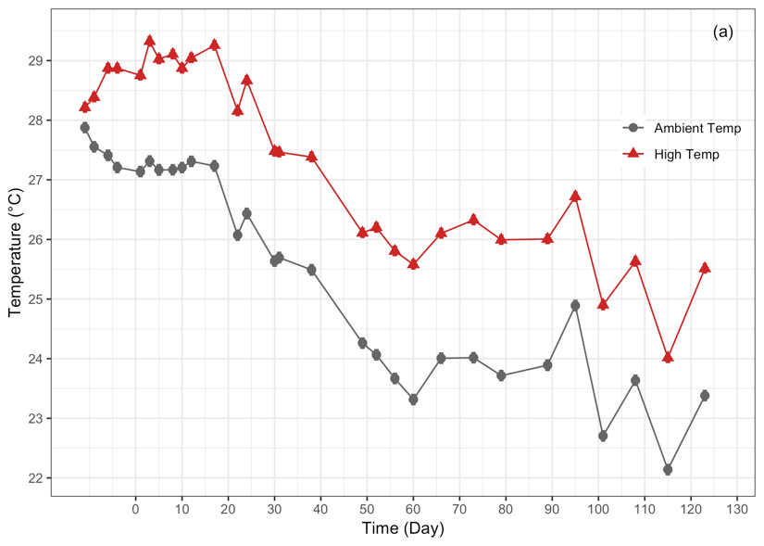

**Figure 3.1.** Temperature (a) and pH (b) conditions over the 126-day experiment period. Data are mean ± standard error (s.e.). Where error bars are not visible, error is too small to be seen. Days prior to 0 indicate the acclimation and conditioning period.

**Effect on Growth**

Test diameters were not significantly different among all urchins upon initial collection (mean = 7.54 ± 0.29 mm; n=24; F3,20=0.851; p=0.4825) or after subsequent ramp-up of conditions (mean = 16.12 ± 0.67 mm; n=24; F3,20=1.0907; p=0.3759). Increased temperatures significantly influenced growth (p = 0.042) while pH did not (p=0.611) (Fig. 3.2). Urchins grown in increased temperatures were 12 % larger than those in ambient conditions, regardless of pH. There was no interaction between temperature and pH (p=0.482) (Fig. 3.2).

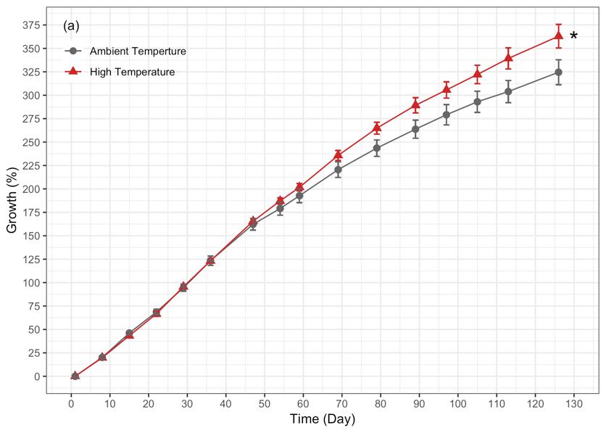

**Figure 3.2.** Effect of (a) temperature and (b) pH on growth (%) of *Tripneustes gratilla* test diameters over the 126-day experiment. Temperature and pH data presented here are pooled for ease of interpretation as there were no significant interactive effects. Data are mean ± standard error (s.e.), n= 11-12, * indicates significance.

**Effect on Calcification**

There was no significant effect of temperature (p=0.387), pH (p=0.437), or the interaction of both (p=0.091) on the calcification ratio of cross-sections at the tips of *T. gratilla* spines. At the base of the spines, pH contributed to a significant reduction of the calcification ratio (p=0.002) while temperature did not (p=0.164). Calcification ratios were 16% lower in acidified conditions, regardless of temperature. There was no interaction between temperature and pH on the calcification ratio at the base of the spines (p=0.536) (Fig. 3.3).

**Figure 3.3.** Effect of temperature and pH on the calcification ratio at the base (a) and tip (b) of spine cross-sections. Data are means ± standard error (s.e.), n = 14-18.

**Effect on Relative Spine Length**

Although marginally nonsignificant, pH influenced relative spine length (% of TD) (p=0.0509) more than temperature (p=0.196). There was no interaction between temperature and pH (p=0.9326) on relative spine length (Fig. 3.4).

**Figure 3.4.** Effect of temperature and pH on the relative spine lengths. Data are means ± standard error (s.e.), n = 51.

**Effect on Spine Dropped**

Low pH significantly increased the number of spines shed on the bottom of the tank regardless of temperature throughout the experimental period (p<0.0001). Urchins in low pH and ambient temperatures shed more spines than those in the control (ambient pH and ambient temperature) (p = 0.004) and ambient pH and high temperatures (p = 0.045). Those in low pH and high temperatures also shed more spines than those in the control (p=0.011) (Fig 3.5).

**Figure 3.5.** Effect of temperature and pH on the number of spines dropped. Data are means + standard error (s.e.), n = 6–7

**Table 3.2.** Summary of ANOVA of individual and combined effects of increased temperature and acidification stress on the biological responses of growth, calcification ratio, relative spine length, and dropped spines at the end of the experimental period (126 days) for *Tripneustes gratilla* based on the statistical models. Bold numbers represent significant effects.

|  |  |  |  |  |
| --- | --- | --- | --- | --- |
| ***Biological Response*** | *Effect* | *df* | *Chisq* | *p* |
|  | Temp | 1 | 4.137 | **0.042** |
| **Growth** | *p*CO2 | 1 | 0.258 | 0.611 |
|  | Temp x *p*CO2 | 1 | 0.534 | 0.465 |
|  |  |  |  |  |
|  | Temp | 1 | 0.749 | 0.387 |
| **Calcification Ratio (Tip)** | *p*CO2 | 1 | 0.604 | 0.437 |
|  | Temp x *p*CO2 | 1 | 2.853 | 0.091 |
|  |  |  |  |  |
|  | Temp | 1 | 1.941 | 0.164 |
| **Calcification Ratio (Base)** | *p*CO2 | 1 | 9.292 | **0.002** |
|  | Temp x *p*CO2 | 1 | 0.383 | 0.536 |
|  |  |  |  |  |
|  | Temp | 1 | 1.798 | 0.196 |
| **Relative Spine Length** | *p*CO2 | 1 | 3.713 | 0.051 |
|  | Temp x *p*CO2 | 1 | 0.001 | 0.933 |
|  |  |  |  |  |

**DISCUSSION**

**Growth**

This research represents one of the few long-term and multi-stressor studies showcasing the effects of both warming and acidification on growth and skeletal development of the ecologically important sea urchin, *Tripneustes gratilla*, from the juvenile to adult life stage. Results demonstrate that near-future predicted conditions of increased temperature (+2°C) positively influenced growth while decreased pH (-0.3 units) negatively affected skeletal components.

These findings are consistent with the general understanding that development and growth for many marine invertebrates are positively correlated to temperature, with warmer temperatures stimulating metabolic activity and increasing growth rates (Przeslawski et al., 2008). However, this temperature-growth relationship is dependent on other variables: food availability, life history, additional stressors etc., and may only hold true to a certain temperature threshold. In addition, it has been documented that climate warming with temperatures past a thermal optimum for a given organism actually results in decreased body size in both terrestrial and aquatic environments (Ohlberger, 2013).

Byrne & Przeslawski (2013) stated that although *T. gratilla* in Australia responded in accordance with a positive growth-temperature relationship, showing increased growth with near-future warming (+2-4°C above ambient), these subtropical populations experience ambient temperatures averaging 20-22°C and are therefore not representative of tropical species that live closer to their thermal maximum.

*Tripneustes gratilla* in Hawaiʻi experience a range of ambient temperatures from as low as 22°C in this study in the winter to as high as 30°C in extreme cases in summer (Bahr et al., 2015). Toha et al. (2017) describes an even bigger range for the global distribution of this species from 15°C in the Red Sea to 32°C in Madagascar. This broad range experienced by *T. gratilla* might allow them to be resilient to changing temperatures, but may also create a risk for tropical populations if their thermal optimum is exceeded.

This study was conducted from October to February, where ambient temperatures began at 27° and dropped to 22°C. The warmest heated condition therefore, reached 29°C at the start and lasted only about 20 days before steadily decreasing. Because these temperatures were within the normal range experienced by this species, it is possible that this result would be different if the experiment were conducted in the summer months, where an added 2°C could have been above the thermal threshold for this species. Acidification did not have a significant effect on growth, as is consistent with findings from a meta-analysis by Dubois (2014a).

**Calcification/ Dissolution**

In this study, the internal network of ossicles in the spine, or the stereom, varied in appearance between individual spines even from the same urchin. Images of cross-sections at the tips were consistent between spines, having a spongy, disorganised appearance (Fig. 4.1 a,b). The bases, on the other hand, were more variable, with 46% of them having the same spongy appearance as the tips (Fig 4.1 c) and the rest having a more structured or patterened appearance (Fig. 4.1 d).

Quantitative analysis of the calcification ratios, the proportion of calcified to non-calcified (void) areas, between treatments indicate that there was no difference in cross-sections of the tips. This is supported by findings from Byrne et al. (2014), where no differences were reported of pore sizes of the tips of *T. gratilla* spines in different pH and warming conditions. However, upon analysis of cross sections at the base of the spines, low pH significantly reduced calcification ratios regardless of temperature. Under ambient pH conditions (regardless of temperatures), only 18% of spine bases had a disorganized appearance. In low pH conditions on the other hand, 72% of the spine bases across temperature treatments had the disorganized, spongy appearance akin to the tips.

a.

b.

c.

d.

**Figure 4.1.** Examples of spine cross-sections of the tips of spines (a,b) and bases (c,d). Each tip/base pair (a/c and b/d) are from the same spine and both spines are from same urchin in a control treatment.

The exact processes of spine calcification and regeneration in echinoderms is complex and not fully understood. The calcite in adult sea urchin forms via an Amorphous Calcium Carbonate (ACC) phase, in which vesicles of ACC are delivered to the site of calcification and eventually transform to the single crystalline calcite structure that make up their high magnesium skeletons (Dubois, 2014a; Politi et al., 2004). Heatfield (1971) summarized the regeneration process of spines of the urchin *Strongylocentrotus purpuratus* as two processes; 1) longitudinal “microspines” grow from the center of the steroem creating the delicate inner zone (Fig. 4.2) and 2) the lateral growth where these “microspines” bifurcate, fuse, and thicken secondarily, forming the dense outer area. The rate of this process depends largely on species and temperature. In *S. purpuratus*, spines grew at a rate of 0.16 mm a day for total regrowth by days 40-60.

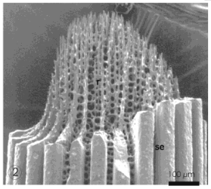

**Figure 4.2**. Initial growth of internal zone “microspines”. (reproduced from Dubois, 2014a)

In more recent research, Dubois & Ameye (2001) added to this understanding with more detail of the involvement of soft tissue in spine regrowth for *S. purpuratus*. For a regenerating spine, it begins with a “wound-healing” phase where the epidermis reforms after 1-2 days and creates a “skeletal-sheath” around the growing tip. Sklerocytes, or skeletogenic cells, are present in this dermis and form the calcification site where the minerals are precipitated. Regeneration from a fracture and complete regrowth of removed spines may differ in the location of initial ACC delivery, with the former having organizational information and involved cells occuring at the site of frature while the latter may be from the mutable connective tissue that attaches the spine to the tubercle. Despite this, it is thought that regeneration and full regrowth occur in a similar manner (Dubois & Ameye, 2001).

The dissolved inorganic carbon needed at the calcification site does not appear directly in the form of calcium carbonate, but rather crosses the biological membranes of urchins as CO2 or HCO32- (Dubois, 2014b). Reduced carbonate concentrations and saturation states of CaCO3 in the surrounding seawater, therefore, are not likely to be the most threatening factors for urchin calcification in acidified conditions (Cryonak et al., 2015; Dubois, 2014b). Instead, it is an organism’s ability to maintain proper carbonate chemistry at the site of calicification. To do this and facilitate the precipitation of CaCO3, an organism must increase the pH at the site, thus lowering the proton concentration ([H+]) and shifting the carbonc acid system towards an increase in carbonate and resulting increase of calcium carbonate saturation state (Ries, 2011). To elevate the pH at the site of calcification, protons must be eliminated, and this process can become costly if the H+ gradient changes with alterations in surrounding seawater pH (Dubois, 2014b; Ries, 2011).

The complexities and intracacies involved in calcification of *T. gratilla* skeletons make it difficult to conclude specifically what mechanisms are occurring under future climate scenarios of warming and acidification. The spongy appearance of the spine steroem in urchin tips and some bases could be due to the age of the spine, with new spines having less time to deposit material and subsequently thicken. Because urchins in acidified conditions shed spines more readily, it is likely that spines were often in a state of new growth. Spines of *S. purpuratus* were found to be fully grown by day 65 following a complete removal (Heatfield, 1971). The marginally shorter spines found on urchins in low pH condition could also be indicative of insufficient time for full regrowth.

In addition to apparent lack of calcification, spines from urchins in low pH conditions appeared to have other malformations or etchings (Fig. 4.3). It is difficult to discern the cause, whether it be difficulty in calcifying or direct dissoltion, of the variable formations in urchin spines from acidified condtions. It is possible that Fig. 4.3c could be indicative of a regenerating spine, as seen in SEM images of regenerating spines of ﻿*Lytechinus variegatus* in acidified conditions by Emerson et al. (2017).

d.

b.

c.

a.

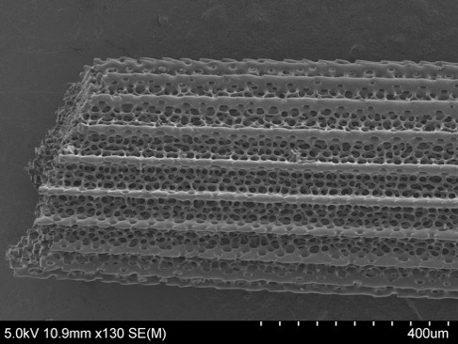 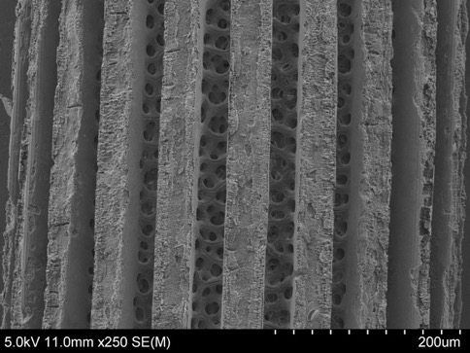

**Figure 4.3**. Scanning Electron Microscope (SEM) images showing the variation in spine formations/deformations of urchins in acidified conditions. Malformation (a, b) could be a result of increased energy cost. Reduction of calcified material (c) could be due to a newer spine or difficulty aquiring material in acidified conditions. Etching (d) may be due to direct dissolution.

**Future Research and Adjustments**

Urchins were housed individually and fed in excess, allowing unrestricted growth. It has been found that ample food availability can offset the negative effects of acidification (Brown et al., 2018; Ramajo et al., 2016). Because these conditions are ecologically unrealistic, it is possible that the addition of predators and/or restriction of food could enhance the negative impacts of warming and acidification. Controlled laboratory experiments, therefore, are not enough to confirm the effects of climate change and should be considered in conjunction with *in situ* research. One study found that individual urchins at CO2 vent sites, where pH can fluctuate <1 unit and averages 7.73 pH units, were actually larger due to increased algal productivity (Uthicke et al., 2016). However, it has also been found that low pH conditions can contribute to lower feeding rates in echinoderms (Clements & Darrow, 2018; Dupont et al., 2013).

While laboratory experiments do not capture all variability that naturally occurs in a given habitat, measures can be taken to ensure realistic outcomes. In this study, seawater was pumped directly in from the surrounding environment to ensure natural fluctuations in both temperature and pH. Treatments were applied on top of this natural variation, allowing conditions to track the surroundings. Kāneʻohe Bay is already warmer and more acidic than the surrounding ocean water (REF), providing interesting insights into the possible adaptibility of organisms that live there.

Results of this study indicate that while warming and acidification conditions expected by 2100 may not be detrimental to survival and growth of *T. gratilla*, there are developmental implications for calcification that could be energitically costly. Future studies should include reproduction and transgenerational patterns, as it is known that gonads are plastic and may be depleted or filled depending on conditions and resource allocation (Dupont & Thorndyke, 2013). In one study, gonads were absent in all urchins reared at pH 7.6 regardless of temperature, indicating potential population instability under projected climate change conditions (Dworjanyn & Byrne, 2018).

**APPENDIX**

**Table 2.2**. Macro script written to convert image selections to binary and determine area to divide images in half.

|  |
| --- |
| macro "Sesno-ify" {  run("Clear Outside");  run("Crop");  roiManager("add");  run("Make Binary");  roiManager("Select", roiManager("count")-1);  run("Remove Outliers...", "radius=2 threshold=50 which=Bright");  run("Remove Outliers...", "radius=2 threshold=50 which=Bright");  roiManager("Rename", getTitle);  //divides current roi into left and right half  getSelectionBounds(x, y, width, height)  getRawStatistics(totalArea);  minOff = 1e9;  for (w=1; w < width; w++){  roiManager("Select", roiManager("count")-1);  setKeyDown("alt");  makeRectangle(x, y, w, height);  getRawStatistics(rightArea);  off = abs(2*rightArea - totalArea);  if (off < minOff){  minOff = off;  xHalf = x + w;  wHalf = w;  halfArea = rightArea;  }  }  //Display result:  roiManager("Select", roiManager("count")-1);  setKeyDown("alt");  makeRectangle(x, y, wHalf, height);  run("Copy");//work around  run("Add to Manager");  roiManager("Select", roiManager("count")-1);  roiManager("Rename", getTitle + "_Right");  //run("Measure");  wait(500);  roiManager("Select", roiManager("count")-2);  setKeyDown("alt");  makeRectangle(x+wHalf, y, width - wHalf, height);  run("Copy");//work around  run("Add to Manager");  roiManager("Select", roiManager("count")-1);  roiManager("Rename", getTitle + "_Left");  //get histogram  roiManager("Select", roiManager("count")-3);  getStatistics(area, mean, min, max, stddev, histogram);  setResult("Skeletal", 0, histogram[255]);  setResult("Void", 0, histogram[0]);  setResult("Ratio", 0, histogram[255]/histogram[0]);  updateResults();    roiManager("Select", roiManager("count")-2);  getStatistics(area, mean, min, max, stddev, histogram);  setResult("Skeletal", 1, histogram[255]);  setResult("Void", 1, histogram[0]);  setResult("Ratio", 1, histogram[255]/histogram[0]);  updateResults();    roiManager("Select", roiManager("count")-1);  getStatistics(area, mean, min, max, stddev, histogram);  setResult("Skeletal", 2, histogram[255]);  setResult("Void", 2, histogram[0]);  setResult("Ratio", 2, histogram[255]/histogram[0]);  updateResults();  setResult("Label", 0, getTitle)  setResult("Label", 1, getTitle + "_Right")  setResult("Label", 2, getTitle + "_Left")  } |

**Table 2.3.**  Final R script conducting statistical modeling.

|  |
| --- |
| **R Markdown documents for all plots and models available. |

**Table 4.1**. Compilation of some recent studies investigating the effects of **warming and ocean acidification** on all life-stages of sea urchins. This listing is restricted to recent publications and are ordered in terms of relevence to this study (preference for same species, long term, juvenile-adult life stages). Results are reported here if there was significance. Abbreviations are as follows: PL= pre-larval, L = larval, J = juvenile (post-metamorphasis), A = adult (60mm), C = control, pHCF = Ceolomic fluid pH

|  |  |  |  |  |  |  |  |  |  |
| --- | --- | --- | --- | --- | --- | --- | --- | --- | --- |
| Taxon | Exposure period | Life Stage | pH | Temp (°C) | Effects Explored | Results | Location | Source | Date |
| *Tripneustes gratilla* | 147 d  (~5 mo) | J-A | C = **8.1**  -0.3 = **7.8**  -0.5 = **7.6** | C = **22**  +3 = **25**  +6 = **28** | Growth (%), wet weight (g),  Gonad index (%),  pHCF | **T**: increased growth and heavier at warmer (25, 28) than ambient (22); lower pHcf at higher T (25, 28)  **pH**: decreased growth at 7.6 than 8.1 (8.1=7.8); lower pHcf at lowest pH (7.6)  **T x pH**: warming increased reprodctive potential while OA decreased (% gonad index), no gonads at all at 7.6. | NSW, Australia | Dworjanyn and Byrne | 2018 |
| *Tripneustes gratilla* | 146 d  (~5 mo) | J-A | C = **8.1**  -0.3 = **7.8**  -0.5 = **7.6** | C = **22**  +3 = **25**  +6 = **28** | Minerology (% MgCO3 and SEM), Test thickness, Crushing force (i.e. test strength) | **T**: increased %MgCO3 in both warmer T (25, 28); weakest test strength at control (22)  **pH**: decreased test strength at two lowest pH (7.8, 7.6)  **T x pH**: low pH reduced test thickness with variation with temperatures | NSW, Australia | Byrne et al. | 2014 |
| *Tripneustes gratilla* | 5 d | L | C = **8.1**  -0.3 = **7.8**  -0.5 = **7.6** | C = **24**  +3 = **27**  +6 = **30** | Larval development (% normal), calcification | **T**: increased growth at + 3°C  **pH**: decreased calcification (7.8, 7.6)  **T x pH**: +3°C diminshed pH effect on growth | NSW, Australia | Sheppard Brennand et al. | 2010 |
| *Paracentrotus lividus* | 343 d  (49 wks,  ~11 mo) | J-A | C = **8.0**  -0.1 = **7.9**  -0.2 = **7.8** | C= **9-15**  +2= **11-18** | Mechanical properties | **T**: no effect  **pH**: no effect  **T x pH**: no effect | Plymouth, UK | Collard et al. | 2016 |
| *Hemicentrotus erythrogramma* | 4 d | PL | C = **8.2**  -0.3 = **7.9**  -0.4 = **7.8**  -0.5 = **7.6** | C = **20**  +2 = **24**  +4 = **26** | Fertilization,  Early development | **T**: reduced cleavage at +4-6°; reduced gastrulation and impaired development at +6°.  **pH**: no effect  **T x pH**: no interaction | NSW, Sydney, Australia | Byrne et al. | 2009 |
| *﻿Arbacia lixula* | 48 h. | L | C = **8.2**  -0.3 = **7.9** | C = **20**  +2 = **24**  +4 = **26** | ﻿larval body profile (size and shape); | **T**: ﻿post-oral length arms, overall length of larvae, and body length affected by increased temperature (24° optimal)  **pH**: ﻿slightly negative effect of pH  **T x pH**: ﻿Morphological traits of the larvae, post-oral length arms, overall length of larvae | ﻿Tyrrhenian Sea, Italy | Visconti et al. | 2017 |
| ﻿*Heliocidaris erythrogramma* | 2 wks  (14 d) | J | C = **8.1**  -0.3 = **7.8**  -0.5 = **7.6**  -0.7 = **7.4** | C = **21**  +2 = **23**  +4 = **25** | Survival, test growth, spine development | **T**:  **pH**:  **T x pH**: Spine development | NSW, Sydney, Australia | Wolfe et al. | 2013 |
| ﻿*Heliocidaris erythrogrammaH. tuberculata, T. gratilla, Centrostephanus rodgersii* |  | PL | C = **8.25**  -0.3 = **7.9**  -0.4 = **7.8**  -0.5 = **7.6** | C = **20**  -2 = **18**  +2 = **22**  +4 = **24**  +6 = **26** | Fertilization | No Effect | NSW, Sydney, Australia | Byrne et al. | 2010 |

**Table 4.2**. Compilation of some recent studies investigating the effects of **ocean acidification** only.

|  |  |  |  |  |  |  |  |  |  |  |
| --- | --- | --- | --- | --- | --- | --- | --- | --- | --- | --- |
| Taxon | Exposure period | Life Stage | | pH | T (°C) | Effects Explored | Results | Location | Source | Date |
| *Tripneustes gratilla, Pseudechinus huttoni,*  *Evechinus chloroticus, Sterechinus neumayeri* |  | | L | C = **8.2**  **6.0, 6.5, 7.0, 7.5, 7.7, 7.8** | A. -1,  NZ =10-15,  Trop = 26 | Somatic and skeletal growth, calcification index, development, survival, SEM | Decreased survival below 7.0 in all species | *Collection*: Antarctica, NZ, Cook Islands  *Conducted*: | Clark et al. | 2009 |
| *Echinometra mathaei* | 6 mo acclimation, 7 mo at conditions | | A | C = **8.1**  -0.4 = **7.7** | 25 | pHCF, Growth, Respiration rate, mechanical properties | No effect | *Collection*: Réunion Is., FR. *Conducted*: Belgium | Moulin et al. | 2014 |
| *﻿Eucidaris tribuloides,*  *Tripneustes ventricosus,*  *Paracentrotus lividus* | 5 wk.  (35 d) | | A | C = **8.1**  -0.4 = **7.7**  -0.7 = **7.4** | 28.4 | pH/alkalinity/DIC of coelomic fluid, Feeding rate | *E. tribuloides*: ﻿no changes within the coelomic fluid  *T. ventricosus* and *P. lividus*: ﻿compensation of the coelomic fluid pH by ﻿increased concentration of DIC in the coelomic fluid (﻿thus of bicarbonate ions) | Discovery Bay, Jamaica | Collard et al. | 2014 |
| *Eucidaris tribuloides, Tripneustes ventricosus* | 5 wk.  (35 d) | | A | C = **8.1**  -0.4 = **7.7**  -0.7 = **7.4** | 28.4 | Dissolution of test plates and spines, spine mechanical properties | *E. tribuloides*: traces of corrosion on secondary spines at 7.4 but no mechanical effects  *T. ventricosus*: etched spines and fracture force reduced at 7.4-7.7 | Discovery Bay, Jamaica | Dery et al. | 2017 |
| *Lytechinus variegatus* | 3 mo.  (~90 d) | | J | C= **8.1**  -0.2=**7.96**  -0.3=**7.83** | 28 | Growth (weight), Skeletal integrity | Heavier in ambient than low pH, spine degradation of spines in highest pH, | Key Biscayne, Florida | Albright et al. | 2012 |
| *Lytechinus variegatus* | 8 wks  (~59 d) | | A | C = **7.9**  -0.2 = **7.7**  -0.5 = **7.4** | 28 | Rate of regeneration, gene expression, structural integrity, physiological fitness (righting response, growth CF.) | Presense of molecular compensatory mechanisms through gene expression, Structural integrety of both regen. And homeostatic spines decrease in low pH. | Mangrove Bay, Bermuda | Emerson et al. | 2017 |
| ﻿*Hemicentrotus pulcherrimus* | 9 mo.  (~274 d) | | L-A | C = 8.1  -0.3 = 7.8 | 18.5 | Survival, growth, gonad devel., egg repro., coelomic fluid pH and [Ca2+]/ [Mg2+], respiration | Survival, growth, respiration not affected. Reduced pHCF, | *Collection*: Sendai, Japan  *Conducted*: Nagasaki, Japan | Kurihara et al. | 2013 |
| *﻿Strongylocentrotus droebachiensis* | ﻿41–45 d | | A | C = **7.9**  -0.3 = **7.6**  -0.6 = **7.3** | 10 | ﻿﻿pH compensation, ossicle growth, skeletal stability | ﻿spines dissolved more severely and were more fragile following acclimatization to high CO2, | ﻿Kattegat, Western Baltic Sea | Holtmann et al. | 2013 |
| *Heliocidaris erythrogramma* | 9 mo  (~274 d) | | A | C = **8.1**  -0.5 = **7.6** | 17 | Skeletal properties (hardness and elasticity)/ microstructure of test and spines | OA grown: ~72% larger pores on plates, ﻿~14% greater porosity and ~17% less biomineral, | NSW, Sydney, Australia | Johnson, et al. | 2020 |
| *Echinometra* sp. EE | 11 mo.  (343 d) | | A | C = **8.1**  -0.4 = **7.7** | 23-26 | Somatic and gonadal growth, gametogenesis, skeletal microstructure | No effects | Eliat, Israel | Hazan et al. | 2014 |

**Table 4.3**. Compilation of some recent studies investigating the effects of **warming** only**.**

|  |  |  |  |  |  |  |  |  |
| --- | --- | --- | --- | --- | --- | --- | --- | --- |
| Taxon | Exposure period | Life Stage | Temp (°C) | Effects Explored | Results | Location | Source | Date |
| ﻿*Diadema antillarum,*  ﻿*Echinometra lucunter* | From wild | A | 22° | Righting behavior (TLOR) in different season | ﻿TLOR increased with increasing temperature | Grand Cayman | Sherman | 2015 |
| *Tripneustes gratilla* | 72 h. | PL, L | ﻿13–34°  (**C** = 23-25°) | Hatching rate, embryonic development, early larval survival | Low and high hatching rates ﻿22°C and 29°C respectively,  ﻿unequal cleavage at 13°C, whereas cleavage did not occurr at 34°C,  ﻿Hatching occured at 16–31°C with maximum at 22–29°C,  ﻿larval temperature tolerance is stage dependent | ﻿Okinawa Island, Japan | Rahman et al. | 2009 |
| *﻿Lytechinus variegatus* | 1 and 10 days | A | **C**=28° **+4**=32° | Covering behavior, righting response, Aristotleʻs lantern reflex | 32°C for 10 days covered with less material and righted less frequently and lantern reflexes less often | Eagle Harbor, FL | Brothers & Mcclintock | 2015 |
| ﻿*Strongylocentrotus intermedius* | 31 w (217 d) | A | **C** = 20°  **+3°** = 23° | ﻿covering, sheltering and righting behaviors | ﻿decreased covering behavior (﻿reaction (time to first covering) and ability (number of covered sea urchins and number of shells used for covering)), ﻿increased sheltering behavior. | North China | Zhang et al. | 2017 |

**REFERENCES**

Albright, R., Bland, C., Gillette, P., Serafy, J. E., Langdon, C., & Capo, T. R. (2012a). Juvenile growth of the tropical sea urchin Lytechinus variegatus exposed to near-future ocean acidification scenarios. *Journal of Experimental Marine Biology and Ecology*, *426*–*427*, 12–17. https://doi.org/10.1016/j.jembe.2012.05.017

Albright, R., Bland, C., Gillette, P., Serafy, J. E., Langdon, C., & Capo, T. R. (2012b). Juvenile growth of the tropical sea urchin Lytechinus variegatus exposed to near-future ocean acidification scenarios. *Journal of Experimental Marine Biology and Ecology*, *426*–*427*, 12–17. https://doi.org/10.1016/j.jembe.2012.05.017

Alexis Dinno, A., & Alexis Dinno, M. (2017). Title Dunn’s Test of Multiple Comparisons Using Rank Sums, 1–7. Retrieved from http://cran.stat.unipd.it/web/packages/dunn.test/dunn.test.pdf

Bahr, K. D., & Jokiel, P. L. (2016). Seasonal and annual calcification rates of the Hawaiian reef coral, Montipora capitata, under present and future climate change scenarios Keisha.

Bahr, K. D., Jokiel, P. L., & Toonen, R. J. (2015). The unnatural history of Kāne‘ohe Bay: coral reef resilience in the face of centuries of anthropogenic impacts. *PeerJ*, *3*, e950. https://doi.org/10.7717/peerj.950

Ban, S. S., Graham, N. A. J., & Connolly, S. R. (2014). Evidence for multiple stressor interactions and effects on coral reefs. *Global Change Biology*, *20*(3), 681–697. https://doi.org/10.1111/gcb.12453

Bates, D., Mächler, M., Bolker, B. M., & Walker, S. C. (2015). Fitting linear mixed-effects models using lme4. *Journal of Statistical Software*, *67*(1). https://doi.org/10.18637/jss.v067.i01

Brothers, C. J., & Mcclintock, J. B. (2015). The effects of climate-induced elevated seawater temperature on the covering behavior , righting response , and Aristotle ’ s lantern re fl ex of the sea urchin Lytechinus variegatus. *Journal of Experimental Marine Biology and Ecology*, *467*, 33–38. https://doi.org/10.1016/j.jembe.2015.02.019

Brown, N. E. M., Bernhardt, J. R., Anderson, K. M., & Harley, C. D. G. (2018). Increased food supply mitigates ocean acidification effects on calcification but exacerbates effects on growth. *Scientific Reports*, (October 2016), 1–9. https://doi.org/10.1038/s41598-018-28012-w

Byrne, M., Ho, M., Selvakumaraswamy, P., Nguyen, H. D., Dworjanyn, S. A., & Davis, A. R. (2009). Temperature, but not pH, compromises sea urchin fertilization and early development under near-future climate change scenarios. *Proceedings of the Royal Society B: Biological Sciences*, *276*(1663), 1883–1888. https://doi.org/10.1098/rspb.2008.1935

Byrne, M., & Przeslawski, R. (2013). Multistressor impacts of warming and acidification of the ocean on marine invertebrates’ life histories. *Integrative and Comparative Biology*, *53*(4), 582–596. https://doi.org/10.1093/icb/ict049

Byrne, M., Smith, A. M., West, S., Collard, M., Dubois, P., Graba-Landry, A., & Dworjanyn, S. A. (2014). Warming influences Mg2+ content, while warming and acidification influence calcification and test strength of a sea urchin. *Environmental Science and Technology*, *48*(21), 12620–12627. https://doi.org/10.1021/es5017526

Byrne, M., Soars, N. A., Ho, M. A., Wong, E., McElroy, D., Selvakumaraswamy, P., … Davis, A. R. (2010). Fertilization in a suite of coastal marine invertebrates from SE Australia is robust to near-future ocean warming and acidification. *Marine Biology*, *157*(9), 2061–2069. https://doi.org/10.1007/s00227-010-1474-9

Clark, D., Lamare, M., & Barker, M. (2009). Response of sea urchin pluteus larvae (Echinodermata: Echinoidea) to reduced seawater pH: A comparison among a tropical, temperate, and a polar species. *Marine Biology*, *156*(6), 1125–1137. https://doi.org/10.1007/s00227-009-1155-8

Clements, J. C., & Darrow, E. S. (2018). Eating in an acidifying ocean: a quantitative review of elevated CO2effects on the feeding rates of calcifying marine invertebrates. *Hydrobiologia*, *820*(1), 1–21. https://doi.org/10.1007/s10750-018-3665-1

Collard, M., Dery, A., Dehairs, F., & Dubois, P. (2014). Euechinoidea and Cidaroidea respond differently to ocean acidification. *Comparative Biochemistry and Physiology -Part A : Molecular and Integrative Physiology*, *174*, 45–55. https://doi.org/10.1016/j.cbpa.2014.04.011

Collard, M., Rastrick, S. P. S., Calosi, P., Demolder, Y., Dille, J., Findlay, H. S., … Dubois, P. (2016a). The impact of ocean acidification and warming on the skeletal mechanical properties of the sea urchin Paracentrotus lividus from laboratory and field observations. *ICES Journal of Marine Science*, *73*(3), 727–738. https://doi.org/doi:10.1093/icesjms/fsv018

Collard, M., Rastrick, S. P. S., Calosi, P., Demolder, Y., Dille, J., Findlay, H. S., … Dubois, P. (2016b). The impact of ocean acidification and warming on the skeletal mechanical properties of the sea urchin Paracentrotus lividus from laboratory and field observations. *ICES Journal of Marine Science*, *73*(3), 727–738. https://doi.org/doi:10.1093/icesjms/fsv018

Conklin, E. J., & Smith, J. E. (2005). Abundance and spread of the invasive red algae, Kappaphycus spp., in Kane’ohe Bay, Hawai’i and an experimental assessment of management options. *Biological Invasions*, *7*(6), 1029–1039. https://doi.org/10.1007/s10530-004-3125-x

Cryonak, T., Schulz, K. G., & Jokiel, P. L. (2015). The Omega myth: what really drives lower calcification rates in an acidifying ocean. *ICES Journal of Marine Science*, *73*(3), 558–562. https://doi.org/10.4135/9781412953924.n678

Dafni, J. (1992). Growth rate of the sea urchin: Tripneustes gratilla elatensis. *Israel Journal of Zoology*, *38*(1), 25–33. https://doi.org/10.1080/00212210.1992.10688663

Dafni, J. M., & Erez, J. (1987). Skeletal calcification patterns in the sea urchin Tripneustes gratilla elatensis ( Echinoidea : Regularia ), (May 2014). https://doi.org/10.1007/BF00409015

Dery, A., Collard, M., & Dubois, P. (2017). Ocean Acidification Reduces Spine Mechanical Strength in Euechinoid but Not in Cidaroid Sea Urchins. *Environmental Science and Technology*. https://doi.org/10.1021/acs.est.6b05138

Dickson, A. G., & Millero, F. J. (1987). A Comparison of the Equilibrium Constants for the Dissociation of Carbonic Acid in Seawater Media, *34*, 1733–1743.

Dickson, A. G., Sabine, C. L., & Christian, J. R. (2007). *Guide to Best Practices for Ocean CO2 Measurements*. *PICES Special Publication 3* (Vol. 3). https://doi.org/10.1159/000331784

Dubois, P. (2014a). The skeleton of postmetamorphic echinoderms in a changing world. *Biological Bulletin*, *226*(3). https://doi.org/10.1086/BBLv226n3p223

Dubois, P. (2014b). The skeleton of postmetamorphic echinoderms in a changing world. *Biological Bulletin*, *226*(3). https://doi.org/10.1086/BBLv226n3p223

Dubois, P., & Ameye, L. (2001). Regeneration of Spines and Pedicellariae in Echinoderms: A Review. *Microscopy Research and Technique*, *55*(6), 427–437. https://doi.org/10.1002/jemt.1188

Dupont, S., Ortega-Martínez, O., & Thorndyke, M. (2010). Impact of near-future ocean acidification on echinoderms. *Ecotoxicology*, *19*(3), 449–462. https://doi.org/10.1007/s10646-010-0463-6

Dupont, S. T., & Thorndyke, M. C. (2013). Direct impacts of near-future ocean acidification on sea urchins. *Climate Change Perspectives from the Atlantic: Past, Present and Future*, (JANUARY), 461–485. Retrieved from http://www.researchgate.net/publication/259978536_Direct_impacts_of_near-future_ocean_acidification_on_sea_urchins/file/3deec52edf976944dc.pdf

Dworjanyn, S. A., & Byrne, M. (2018). Impacts of ocean acidification on sea urchin growth across the juvenile to mature adult life-stage transition is mitigated by warming. *Proceedings of the Royal Society B: Biological Sciences*, *285*(1876). https://doi.org/10.1098/rspb.2017.2684

Emerson, C. E., Reinardy, H. C., Bates, N. R., & Bodnar, A. G. (2017). Ocean acidification impacts spine integrity but not regenerative capacity of spines and tube feet in adult sea urchins. *Royal Society Open Science*, *4*(5). https://doi.org/10.1098/rsos.170140

Fox, J., & Weisberg, S. (2019). An {R} Companion to Applied Regression, Third Edition. *Thousand Oaks CA: Sage.*, (September 2012), 2016. Retrieved from http://socserv.socsci.mcmaster.ca/jfox/Books/Companion

Fung, J. (2014). Urchins and oceans: Effects of naturally occurring water quality on fertilization of the native hawaiian herbivore, Tripneustes gratilla.

Gattuso, J. P., Magnan, A., Billé, R., Cheung, W. W. L., Howes, E. L., Joos, F., … Turley, C. (2015, July 3). Contrasting futures for ocean and society from different anthropogenic CO2 emissions scenarios. *Science*. American Association for the Advancement of Science. https://doi.org/10.1126/science.aac4722

Gorzelak, P., Stolarski, J., Dubois, P., Kopp, C., & Meibom, A. (2011). 26Mg labeling of the sea urchin regenerating spine: Insights into echinoderm biomineralization process. *Journal of Structural Biology*, *176*(1), 119–126. https://doi.org/10.1016/j.jsb.2011.07.008

Hazan, Y., Wangensteen, O. S., & Fine, M. (2014). Tough as a rock-boring urchin: adult Echinometra sp. EE from the Red Sea show high resistance to ocean acidification over long-term exposures. *Marine Biology*, *161*(11), 2531–2545. https://doi.org/10.1007/s00227-014-2525-4

Heatfield, B. M. (1971). Growth of the calcareous skeleton during regeneration of spines of the sea urchin, strongylocentrotus purpuratus (stimpson): A light and scanning electron microscopic study. *Journal of Morphology*, *134*(1), 57–89. https://doi.org/10.1002/jmor.1051340105

Holtmann, W. C., Stumpp, M., Gutowska, M. A., Syré, S., Himmerkus, N., Melzner, F., & Bleich, M. (2013). Maintenance of coelomic fluid pH in sea urchins exposed to elevated CO 2 : The role of body cavity epithelia and stereom dissolution. *Marine Biology*, *160*(10), 2631–2645. https://doi.org/10.1007/s00227-013-2257-x

Inc., S. I. (2019). JMP. Cary, NC.

IPCC. (2019). IPCC Special Report on the Ocean and Cryosphere in a Changing Climate, (September), in preparation. https://doi.org/https://www.ipcc.ch/report/srocc/

Johnson, R., Harianto, J., Thomson, M., & Byrne, M. (2020). The effects of long-term exposure to low pH on the skeletal microstructure of the sea urchin Heliocidaris erythrogramma. *Journal of Experimental Marine Biology and Ecology*, *523*(August 2019), 151250. https://doi.org/10.1016/j.jembe.2019.151250

Jokiel, P. L., Bahr, K. D., & Rodgers, K. S. (2014). Low-cost, high-flow mesocosm system for simulating ocean acidification with CO2 gas. *Limnology and Oceanography: Methods*, *12*(MAY), 313–322. https://doi.org/10.4319/lom.2014.12.313

Kleypas, J. A., Feely, R. A., Fabry, V. J., Langdon, C., Sabine, C. L., & Robbins, L. L. (2006). Impacts of Ocean Acidification on Coral Reefs and Other Marine Calcifiers : A Guide for Future Research. *Atmospheric Research*, *18*, 88. https://doi.org/www.ucar.edu/communications/Final_acidification.pdf

Kroeker, K. J., Kordas, R. L., Crim, R., Hendriks, I. E., Ramajo, L., Singh, G. S., … Gattuso, J. P. (2013). Impacts of ocean acidification on marine organisms: Quantifying sensitivities and interaction with warming. *Global Change Biology*, *19*(6), 1884–1896. https://doi.org/10.1111/gcb.12179

Kurihara, H., Yin, R., Nishihara, G. N., Soyano, K., & Ishimatsu, A. (2013). Effect of ocean acidification on growth, gonad development and physiology of the sea urchin Hemicentrotus pulcherrimus. *Aquatic Biology*, *18*(3), 281–292. https://doi.org/10.3354/ab00510

Lawrence, J. M. (2001). Edible Sea Urchins: Biology and Ecology in Developments in Aquaculture and Fisheries Science.

Mehrbach, C., Culberson, C. H., Hawley, J. E., & Pytkowicz, R. M. (1973). Measurement of the Apparent Dissociation Constants of Carbonic Acid in Seawater At Atmospheric Pressure. *Limnology and Oceanography*, *18*(6), 897–907. https://doi.org/10.4319/lo.1973.18.6.0897

Micael, J., Alves, M. J., Costa, A. C., & Jones, M. B. (2009). Exploitation and Conservation of Echinoderms. *Oceanography and Marine Biology: An Annual Review*, *47*(January), 191–208.

Mos, B., Byrne, M., Cowden, K. L., & Dworjanyn, S. A. (2015). Biogenic acidification drives density-dependent growth of a calcifying invertebrate in culture. *Marine Biology*, *162*(8), 1541–1558. https://doi.org/10.1007/s00227-015-2691-z

Mos, B., Byrne, M., & Dworjanyn, S. A. (2016). Biogenic acidification reduces sea urchin gonad growth and increases susceptibility of aquaculture to ocean acidification. *Marine Environmental Research*, *113*, 39–48. https://doi.org/10.1016/j.marenvres.2015.11.001

Moulin, L., Grosjean, P., Leblud, J., Batigny, A., Collard, M., & Dubois, P. (2014). Long-term mesocosms study of the effects of ocean acidification on growth and physiology of the sea urchin Echinometra mathaei. *Marine Environmental Research*, *103*, 103–114. https://doi.org/10.1016/j.marenvres.2014.11.009

Moureaux, C., Pérez-Huerta, A., Compère, P., Zhu, W., Leloup, T., Cusack, M., & Dubois, P. (2010a). Structure, composition and mechanical relations to function in sea urchin spine. *Journal of Structural Biology*, *170*(1), 41–49. https://doi.org/10.1016/j.jsb.2010.01.003

Moureaux, C., Pérez-Huerta, A., Compère, P., Zhu, W., Leloup, T., Cusack, M., & Dubois, P. (2010b). Structure, composition and mechanical relations to function in sea urchin spine. *Journal of Structural Biology*, *170*(1), 41–49. https://doi.org/10.1016/j.jsb.2010.01.003

Neilson, B. J., Wall, C. B., Mancini, F. T., & Gewecke, C. A. (2018). Herbivore biocontrol and manual removal successfully reduce invasive macroalgae on coral reefs. *PeerJ*, 1–27. https://doi.org/10.7717/peerj.5332

Ohlberger, J. (2013). Climate warming and ectotherm body size - from individual physiology to community ecology. *Functional Ecology*, *27*(4), 991–1001. https://doi.org/10.1111/1365-2435.12098

Pierrot, D., Lewis, E., & Wallace, D. W. R. (2006). MS Excel Program Developed for CO2 System Calculations. Oak Ridge: Carbon Dioxide Information Analysis Center; Oak Ridge National Laboratory, U.S. Department of Energy. https://doi.org/10.3334/CDIAC/otg.CO2SYS_XLS_CDIAC105a

Politi, Y., Arad, T., Klein, E., And, S. W., & Lia, A. (2004). Sea Urchin Spine Calcite Forms via a Transient Amorphous Calcium Carbonate. *Science*, *306*(5699), 1161–1164.

Przeslawski, R., Ahyong, S., Byrne, M., Wörheide, G., & Hutchings, P. (2008). Beyond corals and fish: The effects of climate change on noncoral benthic invertebrates of tropical reefs. *Global Change Biology*, *14*(12), 2773–2795. https://doi.org/10.1111/j.1365-2486.2008.01693.x

Rahman, M. A., Arshad, A., & Yusoff, F. (2014). Sea Urchins (Echinodermata: Echinoidea): Their Biology, Culture and Bioactive compounds. https://doi.org/10.15242/iicbe.c714075

Rahman, S., Tsuchiya, M., & Uehara, T. (2009). Effects of temperature on hatching rate, embryonic development and early larval survival of the edible sea urchin, Tripneustes gratilla. *Biologia*, *64*(4), 768–775. https://doi.org/10.2478/s11756-009-0135-2

Ramajo, L., Pérez-león, E., Hendriks, I. E., Marbà, N., Krause-jensen, D., Sejr, M. K., … Duarte, C. M. (2016). Food supply confers calcifiers resistance to ocean acidification. *Nature Publishing Group*, (December 2015), 1–6. https://doi.org/10.1038/srep19374

Ries, J. B. (2011). A physicochemical framework for interpreting the biological calcification response to CO2-induced ocean acidification. *Geochimica et Cosmochimica Acta*, *75*(14), 4053–4064. https://doi.org/10.1016/j.gca.2011.04.025

Ries, J. B., Cohen, A. L., & McCorkle, D. C. (2009). Marine calcifiers exhibit mixed responses to CO2-induced ocean acidification. *Geology*, *37*(12), 1131–1134. https://doi.org/10.1130/G30210A.1

Sheppard Brennand, H., Soars, N., Dworjanyn, S. A., Davis, A. R., & Byrne, M. (2010). Impact of ocean warming and ocean acidification on larval development and calcification in the sea urchin Tripneustes gratilla. *PLoS ONE*, *5*(6), 1–7. https://doi.org/10.1371/journal.pone.0011372

Sheridan, J. A., & Bickford, D. (2011). Shrinking body size as an ecological response to climate change. *Nature Climate Change*, *1*(8), 401–406. https://doi.org/10.1038/nclimate1259

Sherman, E. (2015). Can sea urchins beat the heat ? Sea urchins , thermal tolerance and climate change. https://doi.org/10.7717/peerj.1006

Stimson, J., Cunha, T., & Philippoff, J. (2007). Food preferences and related behavior of the browsing sea urchin Tripneustes gratilla (Linnaeus) and its potential for use as a biological control agent. *Marine Biology*, *151*(5), 1761–1772. https://doi.org/10.1007/s00227-007-0628-x

Team, R. C. (2018). R: A language and environment for statistical computing. Vienna, Austria.: R Foundation for Statistical Computing. Retrieved from https://www.r-project.org/

Toha, A. H. A., Sumitro, S. B., Hakim, L., Widodo, N., Binur, R., Suhaemi, S., & Anggoro, A. W. (2017). Review: Biology of the commercially used sea urchin Tripneustes gratilla (Linnaeus, 1758) (Echinoidea: Echinodermata). *Ocean Life*, *1*(1), 1–10. https://doi.org/10.13057/oceanlife/o010101

Tsafnat, N., Fitz Gerald, J. D., Le, H. N., & Stachurski, Z. H. (2012). Micromechanics of Sea Urchin Spines. *PLoS ONE*, *7*(9). https://doi.org/10.1371/journal.pone.0044140

Uthicke, S., Ebert, T., Liddy, M., Johansson, C., Fabricius, K. E., & Lamare, M. (2016). Echinometra sea urchins acclimatized to elevated pCO2 at volcanic vents outperform those under present-day pCO2 conditions. *Global Change Biology*, *22*(7), 2451–2461. https://doi.org/10.1111/gcb.13223

Visconti, G., Gianguzza, F., Butera, E., Costa, V., Vizzini, S., Byrne, M., & Gianguzza, P. (2017). Morphological response of the larvae of Arbacia lixula to near-future ocean warming and acidification. *ICES Journal of Marine Science*, *74*(4), 1180–1190. https://doi.org/10.1093/icesjms/fsx037

Westbrook, C. E., Ringang, R. R., Cantero, S. M. A., & Toonen, R. J. (2015). Survivorship and feeding preferences among size classes of outplanted sea urchins, Tripneustes gratilla , and possible use as biocontrol for invasive alien algae. *PeerJ*, *3*, e1235. https://doi.org/10.7717/peerj.1235

Wolfe, K., Dworjanyn, S. A., & Byrne, M. (2013). Effects of ocean warming and acidification on survival, growth and skeletal development in the early benthic juvenile sea urchin (Heliocidaris erythrogramma). *Global Change Biology*, *19*(9), 2698–2707. https://doi.org/10.1111/gcb.12249

Zhang, L., Zhang, L., Shi, D., Wei, J., Chang, Y., & Zhao, C. (2017). Effects of long-term elevated temperature on covering, sheltering and righting behaviors of the sea urchin *Strongylocentrotus intermedius*. *PeerJ*, *5*, e3122. https://doi.org/10.7717/peerj.3122